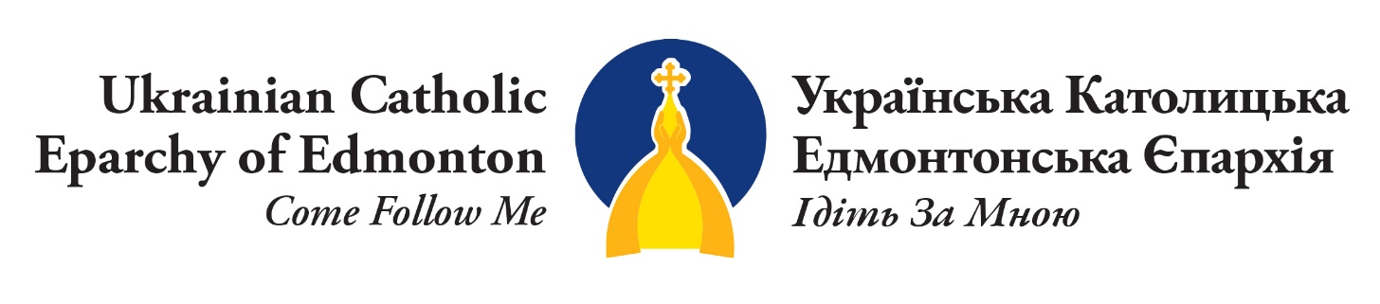

May 4, 2022
Humanitarian Aid Settlement Grant For Eparchial Parishes

Purpose
The Humanitarian Aid Settlement Grant provides funds to parishes of the Eparchy of Edmonton undertaking projects to help with the settlement of Ukrainian Nationals fleeing the invasion of Ukraine by the Russian Federation which began February 24, 2022. This grant will support specific projects that will help individuals and families settling in Alberta. As the faithful of our Eparchy prepare to welcome these people, we understand that each parish may have different means of providing support. All parishes are encouraged to be innovative in their ideas.
To date, the Eparchy of Edmonton has received many generous donations from parishioners, friends, various organizations and businesses. $200,000 of these donations are set aside by the Eparchy to help the families settling in Alberta.
Requirements and Eligibility
- This grant is only available to parishes belonging the Eparchy of Edmonton.
- The maximum grant amount is $10,000 per project/per parish.
- Priority will be given to requests of an urgent nature. Grants may include funding for: welcome events, orientation programs, day camps, overnight camps, English lessons, spiritual and psychological counselling, the purchase of essential goods, etc.
- At this time, grants are only used to support Ukrainian Nationals who are fleeing the war and who arrived in Canada after February 24, 2022.
- Grant funding cannot be used to purchase gift cards or to provide cash to individuals, nor can they be used to pay for parish/household improvements (even if this is for the intent of housing displaced persons).
- Parish volunteers for these projects may be required to undergo Safer Environments training, depending on the project/activity
- Eligibility for this grant is based on several factors including: type of project, number of persons it will support, potential for a long-lasting benefit for families/parishes, etc.

How to Apply
Please complete the following application, including all supplementary documents, and submit to the Pastoral Centre chancery@edmontoneparchy.com Once the application is reviewed, the parish will be notified regarding its status and the amount approved, if successful.
Contact
Questions may be directed to Iryna Laschuk 780 424 5496 or accounting@eeparchy.com.

Humanitarian Aid Settlement Grant
Part 1: Contact Information
Parish name, address, and pastor

Contact name, phone number and position in the parish

Part 2: Project Scope
Project Name

Project Description

Who will benefit from this project? How many people do you expect to help?

Who will be responsible for the project?

Timeline of the project (proposed start date and end date)

Part 3: Financial Information
Please be specific in completing the budget. A final financial report is required at the end of the project or fiscal year, whichever comes first.
Total project budget

Grant amount being applied for

Detailed budget outlining all projected expenses (please attach)

Have any other organizations been asked to support this project through monetary donations, volunteers, or partnering?

Part 4: Disclaimer
All successful applicants agree to have their projects posted on the eparchial website www.eeparchy.com.
Upon completion of the project, the parish will submit a final project report.

Part 5: Final Report
Either after the project is complete or by December 31 of the current year (whichever comes first), a final report or a progress report is to be submitted to Director of Finance accounting@edmontoneparchy.com . This report will include:
- summary of the project including successes and lessons learned
- pictures, anecdotes and testimonials
- financial statement with all receipts

Part 6: Approval Signatories on Behalf of the Parish
Submit this completed application to: Pastoral Centre
9645 – 108 Avenue, Edmonton AB T5H 1A3
chancery@edmontoneparchy.com

Pastor’s Name: ________________________________________
Signature: ____________________________________________ Date: __________________

Pastoral Council Chair: _________________________________
Signature: ____________________________________________ Date: ___________________

Pastoral Council Treasurer: _____________________________
Signature: ___________________________________________ Date: ___________________

