The Entrance of the Holy Mother of God into the Temple Icon
This article was published on www.eeparchy.com
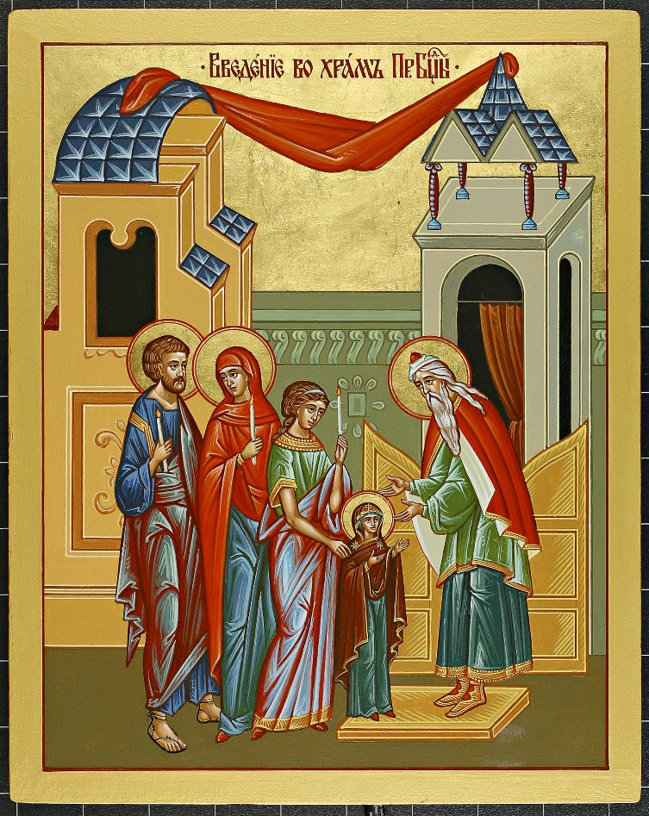
What we know about the Entrance of the Theotokos into the temple comes to us from Sacred Tradition. The most significant source that speaks about the early life of the Mother of God is the Protoevangelium of James. We learn that Joachim and Anna, who were childless for many years, are granted the miracle of conceiving a child in their old age. They bring their daughter Mary to the temple at the age of three as they had vowed to God that they would. Concerned that she might turn back to her parents, Joachim gathers the holy Hebrew virgins to form a procession with lighted lamps thus intriguing her and directing her into the temple. In the icon, we see one of these young women standing directly behind the child Mary. Other icons of the event depict the procession with several young women. Joachim and Anna stand behind them. The High Priest Zacharias greets the holy family and with arms outstretched, receives the child into the temple; a child who herself will become the “Holy Temple of God.” The Theotokos reaches her hands out to him. We are reminded of her complete, humble and trusting openness to the will of God and the “yes” that she will give when she is later asked to bear the Son of God. Behind Zacharias the temple is depicted. We see the red curtain which separates the Holy of Holies from the rest of the temple. It is here that Zacharias takes the young child and places her on the third step of the holy altar. Only the high priest was allowed to enter this sacred place and at that, only once a year. The Theotokos is the “living tabernacle.” She belongs on the altar. God is preparing for himself a Holy dwelling place. The Theotokos is the model for our own humanity. In our lives let us open our arms to the will of God and become ourselves temples of the Holy Spirit as God has called us to do.

