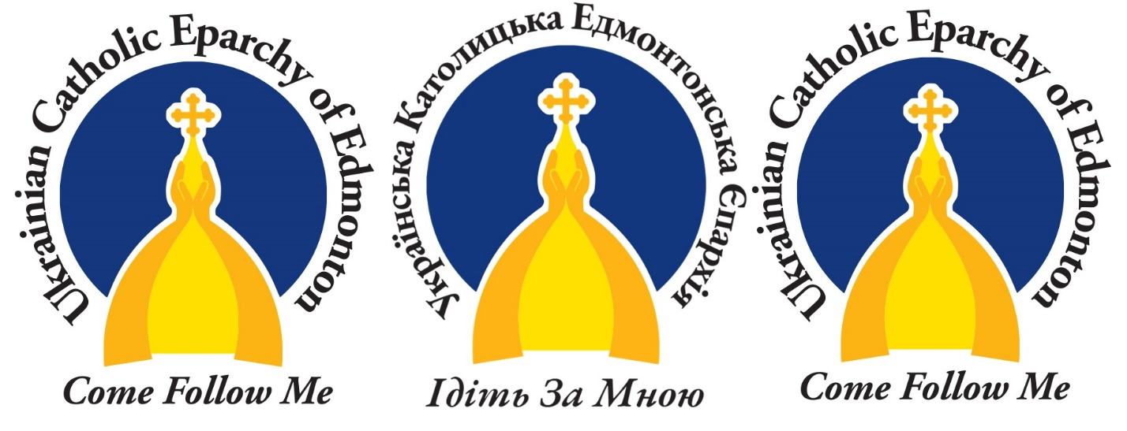

Our New Symbol of Faith and Hope
This article was published on www.eeparchy.com

As a part of the Edmonton Eparchy’s Evangelize 2021 campaign, we reached out to our community to help us design a new logo for our Eparchy, an image that specifically represents our common mission of the Church, to evangelize and share the Good News of the Gospel of Jesus Christ with everyone, no matter where they are on their faith journey.

What it represents…
The golden church dome under a vivid blue sky was a steadfast symbol of faith and hope for the Ukrainian Catholics who ventured into the harsh conditions of the new world. Today, it remains a recognizable image that is familiar and welcoming to all Albertans, no matter their background.

In this representation, logo designer Julian Hayda modelled his dome after St. Mary Ukrainian Catholic Parish in Waugh, Alberta. He explains, “What you see here are two paths, beginning at both East and West, and converging at a pinnacle as two hands holding one cross together.” He is referring to Eastern Catholics in full communion with Rome, joined in the one Catholic Church. The arms reaching upward also reflect our ardent desire to enter into communion with the awesomeness of God through the sacrificial love of Christ represented by the cross.

Here, as in classical iconography, the colour blue also represents divinity. The darker the blue, the more deeply we enter into the life of the Holy Trinity. The circle stands for the eternal nature of God – without beginning or end. As such, God’s love for us is eternal – a mystery beyond our understanding. In contrast, the golden dome reflects the glory of God, the Divine Light visible to us. Its shape reminds us of the vault of heaven where we experience the embrace of the living God, especially through the Holy Mysteries, the Eucharist in particular.

Finally, an invitation, “Come follow me.” Christ who called the first disciples, also calls each and every one of us to follow him. A relatable and inspiring image, the logo of the Eparchy of Edmonton reflects the mission of the Church, to evangelize and share the Good News of the Gospel of Jesus Christ with everyone, no matter where they are on their faith journey.

