Icon of the Protection of the Most Holy Mother of God
This article was published on www.eeparchy.com
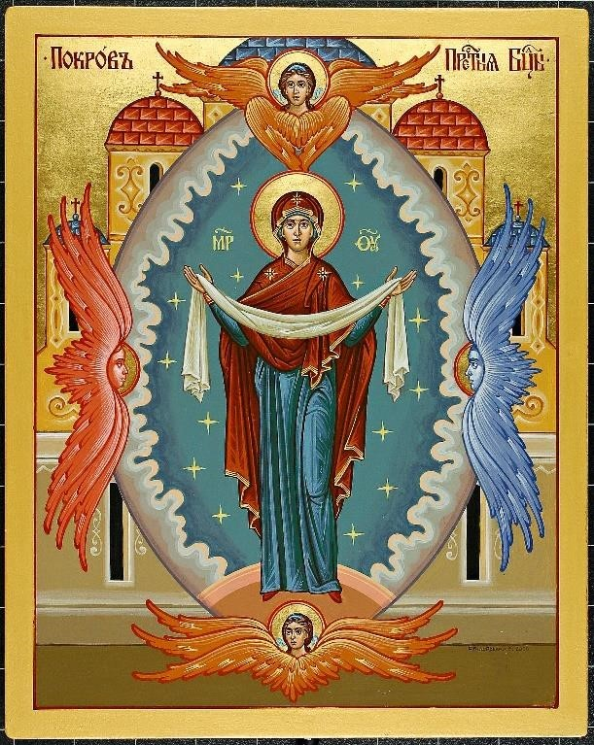
The icon showing the Theotokos standing with her arms outstretched in prayer and draped in a veil (omophorion – Pokrov) recalls the story of her miraculous appearance in the Blachernae church in Constantinople likely in the mid-tenth century. This occurred one night as the church was filled with the faithful praying for deliverance from enemies. St. Andrew, known as the Fool for Christ, and his disciple Epiphanius saw the Theotokos enter the church and face the sanctuary. There she tearfully prayed for a long time after which she approached the Bishop’s Throne and continued her prayer. Then taking her veil she turned to those present, and held it out over them, showing her intention to protect them from enemies both visible and invisible. In the icon she holds the omophorion and is flanked by angels. This is a meeting of heaven and earth. Behind her we see the Mandorla or nimbus, reminding us of this presence of heaven on earth. In the background are the multiple domes depicting the Cathedral of Blachernae where the event took place.

The feast of “Pokrov” is not one of the 12 major feasts of the liturgical year. However, it holds a special place in the hearts of the Ukrainian people who posses a great love and devotion to the Mother of God and look to her as their protectress. In 1036, Prince Yaroslav the Wise built the Church of Assumption in Kyiv after a great victory at war. In 1037, in that same church, he entrusted the entire nation to her guardianship. The appearance of the Mother of God at the Pochaiv monastery in Ukraine, during a Turkish siege in 1675 is familiar to most Ukrainians. In response to the fervent prayers of the monks and the faithful, the Theotokos appeared over the monastery church and held out her omophorion (veil) as she did in Blacharnae.
This feast is also referred to as the Protection of the Most Holy Mother of God, The Patronage of the Most Holy Mother of God, The Patronage of the Theotokos, The Protection of the Blessed Virgin Mary and the Protection of the Theotokos.
Through the celebration of this feast we are reminded of the unending protection that is ours through the intercession of the Most Holy Theotokos and we are encouraged to flee to her mercy and compassion at all times of trouble.

