Icon of the Annunciation of the Most Holy Mother of God
This article was published on www.eeparchy.com
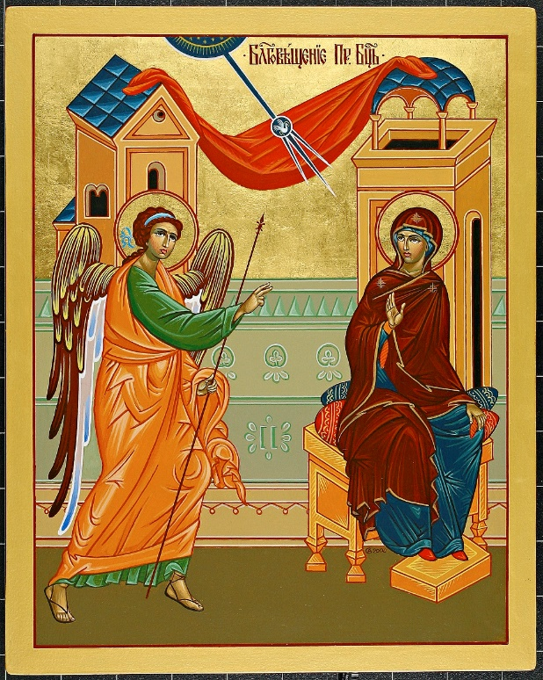
We celebrate the Feast Day of the Annunciation on March 25; nine months before the celebration of the Nativity of Our Lord. We read about the event in the Gospel of Luke 1:2638. We also learn of it in the Protoevangelium of James which is a document from the Sacred Tradition of the Church. This document gives us much of the information we know about the early life of the Theotokos (literally Godbearer).

The two figures depicted in the icon are the angel Gabriel and the Theotokos. Behind them, is a red draped cloth telling us that this scene takes place in an interior.

At the top of the icon is a circle (the vault of Heaven) from which radiates a shaft of light towards Mary. As it comes down toward her, it breaks into three shafts, signifying the Trinity. Within the circle where the light breaks into three, there is a dove; the symbolism of the Holy Spirit. This indicates the special role of the Holy Spirit in this event, as the angel Gabriel tells her “the Holy Spirit will come upon you.” (Luke 1:35)

The angel is holding a staff in his hand, which in icons, is an indication that he is a messenger. He stands with his feet spread apart with heels lifted as if in a running position. Many icons also show his wings blowing behind him. We sense the movement and the urgency as he moves swiftly to deliver his all-important message. His right hand is outstretched in blessing as he calls to her “Greetings favoured one the Lord is with you!” (Luke 1:28)
The Protoevangelium of James tell us that Mary was assigned the task of preparing the purple and scarlet material to be used for the making of the veil in the Temple. We see that she was dutifully carrying out this assignment before her heavenly visitor’s arrival. In her hand she holds a spindle of scarlet yarn.

The Theotokos is depicted here as she usually is in icons, with three stars on her garments, symbolizing her perpetual virginity, before, during, and after the birth of Christ. She sits on what appears to be a throne, revealing the heights at which she is regarded: “more honourable than the cherubim and by far more glorious than the seraphim…Hymn to the Mother of God. She looks toward the angel. Her right hand is raised in a gesture indicating acceptance and at the same time, prudent hesitancy in her response to Gabriel’s message that she will bear the Son of God. At first, she asks the questions “How can this be?” and receiving the answer, immediately responds with a perfect surrender to the will of God “Here am I, the servant of the Lord; let it be with me according to your word.” (Luke 1:38).

Today is the beginning of salvation! At this moment the Theotokos shows her utmost trust and willingness to work with God in the plan of salvation. May we all be moved in our lives to be so open and willing to live according to His will, even if that might sometimes mean turning our own plans for our lives upside down.

