Explanation of the Icon of the Transfiguration of Christ
This article was published on www.eeparchy.com
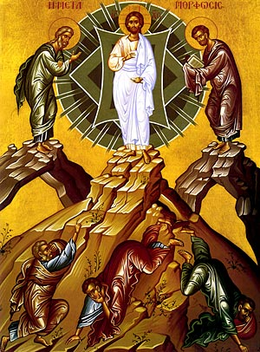
The event of the Transfiguration of Christ was a theophany, (a manifestation of the Holy Trinity) and therefore we can see similarities in this icon with that of the Theophany (the baptism of Jesus in the Jordan). In this event the Son is revealed in the person of Jesus; the Spirit in the bright, overshadowing cloud; and the Father in the voice from the cloud. Behind Jesus is the Mandorla or nimbus, the tri-colour blue shape which represents the divine glory and majesty of God beyond that which can be physically witnessed. The geometric figure within the Mandorla represents the Holy Spirit which comes in the cloud that descends upon the scene. While he was still speaking, suddenly a bright cloud overshadowed them Mt. 17:5.
In the event of the Transfiguration of Christ, the three Apostles Peter, James, and John are permitted to experience the glory of God only as much as they can bear. And he was transfigured before them, and his face shone like the sun, and his clothes became dazzling white. Mt. 17:1-9. We see that they have been overwhelmed with even this much of an experience of God’s glory as they are “knocked off their feet.” Peter on the left is kneeling as he realizes that he is truly in the presence of God. Shortly before this event he had professed his belief that Jesus is the Messiah, therefore his eyes and heart are open to what he is seeing. He said to them, “But who do you say that I am?” Simon Peter answered, “You are the Messiah, the Son of the living God.”. Mt. 16:15-16. With his hand Peter points as he says: “Lord, it is good for us to be here; if you wish, I will make three dwellings here, one for you, one for Moses, and one for Elijah.” Mt. 17:4.
James on the right has fallen over backwards with his hands over his eyes. This experience has burned itself within him. For us he represents hope, since in the near future, because of what he has seen, he will have the courage of faith to be the first of the 12 Apostles to be martyred.
John in the centre lies directly under the transfigured Christ. He will soon be standing directly under the Him as He hangs upon the cross. This glorious revelation of the light of the Resurrection will strengthen John for what is to come.
Christ is blessing all with his right hand and holding a scroll in his left. His blessing reminds us of His abiding love for all of us and the scroll is the “Good News” of the Gospel. Christ is the “Living Word of God”.
Elijah and Moses stand at the top of mountain peaks on each side of Christ. These two holy men represent the Law and the Prophets. Moses, on Christ’s left-hand side holds the book of the law which he received from God. It is significant that the prophet Elijah is at the right hand of Christ where John the Baptist stands in the icon of Theophany, thus linking again to the first great theophany in the life of Christ. As do all the prophets, both Elijah and John ultimately point us to Christ.
Other matters to note: Both of these men experienced visions of God on mountains: Moses on Mount Sinai and Elijah on Mount Carmel and here they stand again on a mountain sharing in that experience with Peter, James and John. Elijah, because he was taken up into heaven by a chariot of fire, represents the living and Moses, because he died before experiencing the promised land, represents those who have died. All the living and the dead are saved through Christ.
This event came at a critical point in the ministry of our Lord, just as He was setting out on His journey to Jerusalem where He would experience humiliation, suffering, and death on the Cross. This glimpse of His glory and ultimately the glory which we will all share in, was meant to strengthen the three men (and us) for the suffering of the cross.
In our life as Christians, the Holy Eucharist is the sacrament of the transfiguration. We receive a “taste” of heaven, and we are transfigured. We are meant to go out and in turn transfigure the world with the light of Christ.
The feast of the Transfiguration of Christ gives us hope and we look forward to the great and glorious Second Coming of Christ. We await the fulfillment of the Kingdom of God when all of creation will be transfigured and filled with the light of Christ.

