Exaltation of the Precious and Lifegiving Cross Icon
This article was published on www.eeparchy.com
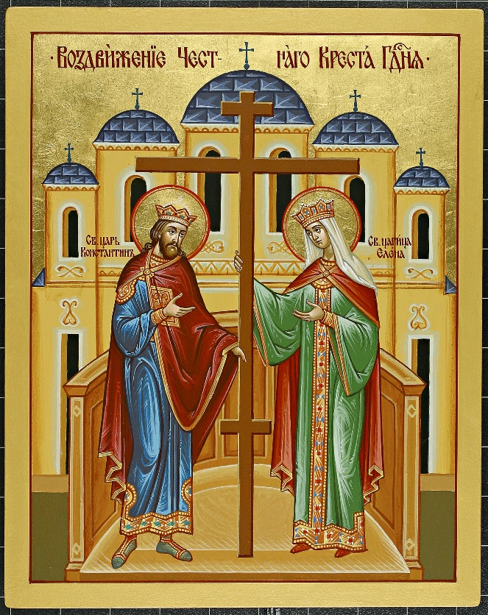
The feast is referred to as the Exaltation of the Holy Cross, Elevation of the Precious and Lifegiving Cross or Exaltation of the Precious and Lifegiving Cross. On this day we commemorate the finding of the true cross of Christ in the year 326, by St. Helena (mother of the emperor Constantine). In the year 335, the Basilica of the Resurrection, also known as the Church of the Holy Sepulchre, was built in the place where the cross was discovered on Golgotha in Jerusalem. The consecration of this Basilica took place on Sept 13 of that year. The cross of Christ was elevated and exalted in a solemn ceremony in the church the next day: Sept.14. Three hundred years later, in 614 the cross was stolen by the Persians and recovered again by Emperor Heraclius in 628. He is sometimes depicted in icons of the Exaltation of the Holy Cross. It was elevated again on Sept 14, 628. This holy feast day has been observed ever since.
In the icon above, St. Helena and St. Constantine are depicted on either side of the Holy Cross. In the background we see the great Basilica of the Resurrection. St. Constantine had experienced a miraculous vision of the cross which lead him to ending the persecution of the Christians in 313. He is considered by many to be the first Christian Emperor. His mother St. Helena was instrumental in this conversion.

The icon of the Exaltation of the Holy Cross reinforces in the viewer’s mind the centrality of the cross for the Christian. It is the focus of the icon; our eye is drawn to it and in life our hearts are drawn towards it. The cross, once ugly, is for Christians a beautiful sign of victory, love, and eternal life. Each time we make the sign of the cross on ourselves, it is good for us to remember that we are recognizing Christ’s victory over death and are recommitting ourselves to our God who loved us so much that He gave His only Son for our sake.

