Dormition of the Holy Mother of God Icon
This article was published on www.eeparchy.com
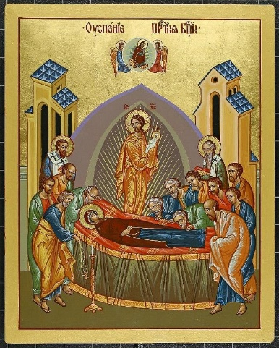
The Theotokos (Mother of God) is lying on her deathbed surrounded by the apostles who have come miraculously from around the globe to be with her. Read more about it here. Christ is central to the icon along with His mother. Together their bodies form a cross reminding us of the ultimate victory over death which Christ has accomplished, and which was made possible by the freely given, unequivocal “yes” of Mary to be the Mother of God. Behind Our Lord is a Mandorla or nimbus, the tri-colour blue shape which represents the divine glory and majesty of God beyond that which can be physically witnessed. A heavenly reality bursts into the earthly reality. This moment of the Dormition of Mary is truly a meeting of heaven and earth.
As her body lies in peace, Jesus stands receiving her spotless soul. This is represented by the figure of a small child “wrapped in swaddling clothes” that He holds in His arms. This is reminiscent of when Mary accepted Jesus on earth. Jesus now accepts her into heaven. At the top of the icon we see her seated on a throne. She is the Queen of heaven and we see a Mandorla behind her as she is now in heaven with her beloved Son. The angels accompany her, carrying her to heaven.
Along with the apostles are two bishops usually identified as St. James, the first bishop of Jerusalem and Timothy a convert.
The Icon for the Feast of the Dormition of the Holy Mother of God shows the reverence and sorrow (heads bent low) of the apostles that surround her, but more than that, it reveals eternal hope. Here, we witness the goal of the perfect life. We, as Christians who stumble through life are also destined to join our Saviour in heaven. We look to the Mother of God (Theotokos) and our mother to be a guide to us and we pray to her for her intercession. We are hopeful because she has shown us that our own death is but a transition; a passage to eternal life with Christ. It is significant that the Dormition of the Holy Mother of God is the final feast day of the liturgical year because this feast turns our focus towards our own final goal of this earthly life: eternal life in heaven.

