“I really felt beloved!”

*24-hours of tranquility at women’s retreat*

By Jayne L. Buryn, Communications Coordinator, Ukrainian Catholic Eparchy of Edmonton

May 9, 2018: From 6:30 p.m. on Friday April 20 to 6:30 p.m. on Saturday, April 21, 19 women of all ages joined together for a “time of rest in the Lord, away from the busyness of life.” An atmosphere of tranquility prevailed at the Ukrainian Catholic Eparchy of Edmonton Camp Oselia, 45 minutes west of Edmonton as the women participated in the retreat “Living as God’s Beloved: An invitation to Dance.” The nature surrounding the facility enfolded retreatants in a sacred stillness.

Through times of prayer, silent reflection and sharing, retreat participants experienced the grace of being God’s beloved “in our blessedness, our brokenness and gifts we were called to offer … others.

Many of the women said they really appreciated having the variety of ages.

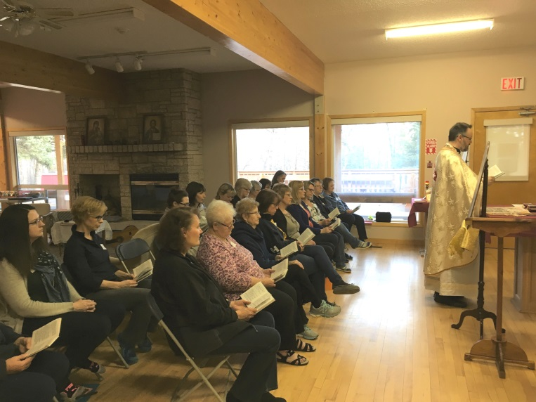Fr. Jim Nakonechny celebrated a Divine Liturgy with us.  “It was beautiful!” noted Bernadette Mandrusiak, eparchial director of education and retreat organizer.

“Many participants appreciated the age distribution and the small group sharing,” said Bernadette, “and felt safe to share in this caring atmosphere.”

Others found inspiration in the Friday evening chanting of the Jesus Prayer before icons and the beautiful singing during the liturgy and the sessions.

The facilitator provided “thought-provoking stories”, such as “the most beautiful heart”.*

The retreat experience “affirmed my faith that God is all around me and will never forsake me!” said one retreat participant. Another added that “I really felt beloved!”

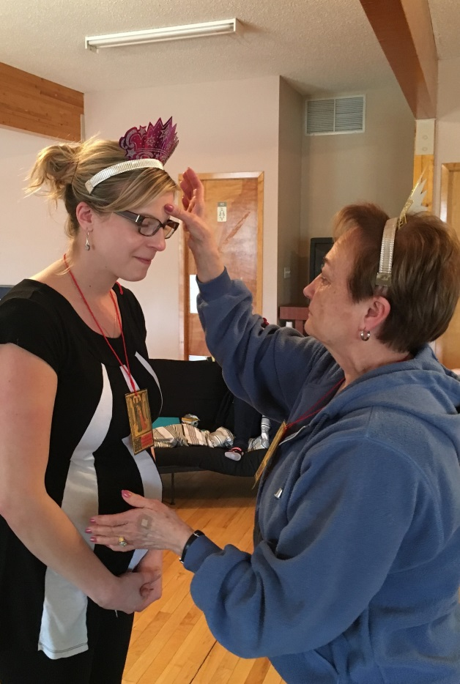

**Performing Rituals**

*Photos submitted*

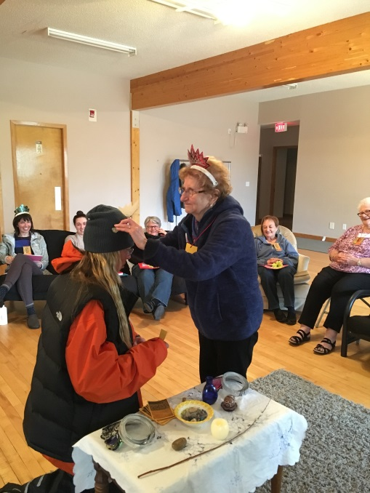

*Performing a ritual, Christina Chernyansky and Joyce Chrunik-Rudiak*

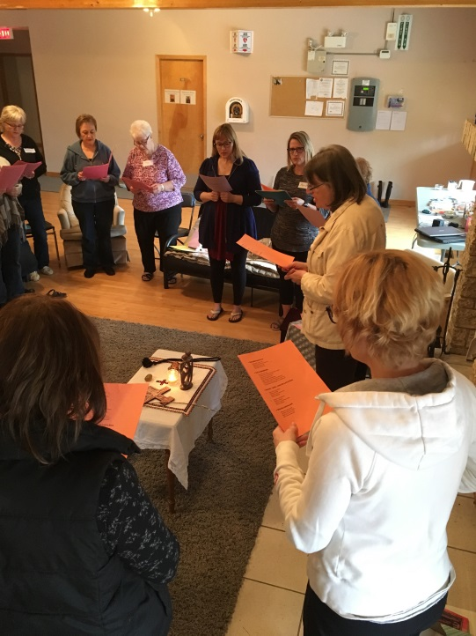

*Praying together*

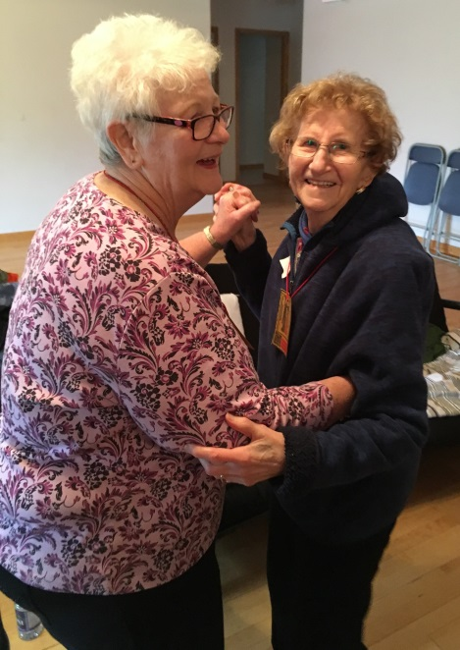

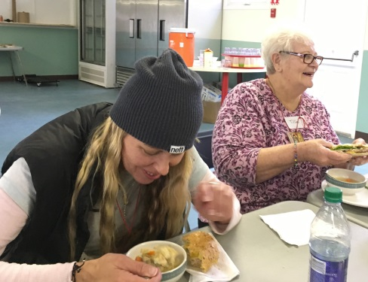On Saturday retreatants broke bread together at breakfast, lunch and supper and enjoyed additional snacks throughout their time together. They followed three “sacred rules” during the retreat: listening to each other without comment or discussion when sharing of themselves in the full group and during the *Lectio Divina*, maintaining confidentiality and sacred stillness in the main retreat and sleeping areas. “The dining room was reserved for socializing.”

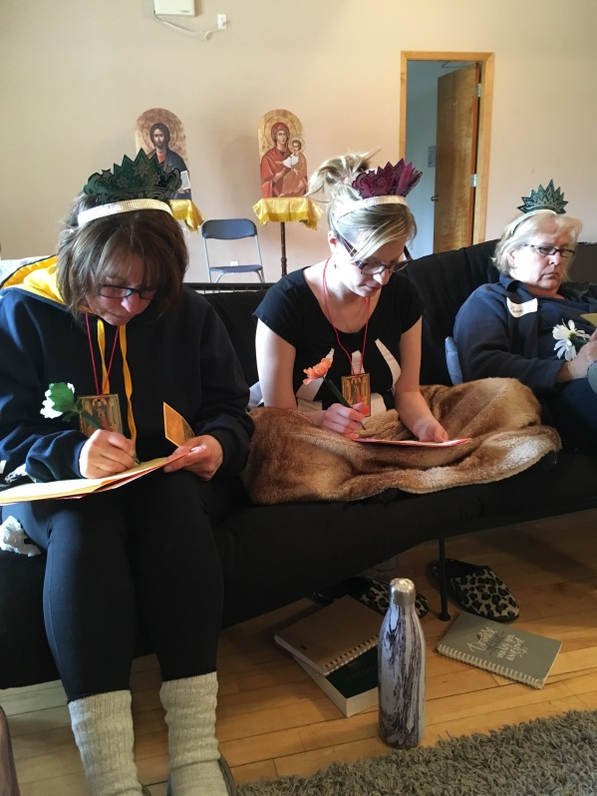

*Individual reflection*

Topics and activities of the retreat included: “Letters from God”, individual silent reflection and questions, chanting of the *Jesus Prayer*, performing rituals and sharing with companions or the group as a whole.

Jesus Prayer: "Lord Jesus Christ Son of God, have mercy on me a sinner."

“We hope to do another retreat like this next spring,” says Bernadette Mandrusiak.  “We are planning to hold a follow-up faith-sharing group for Catholic women. It is called “Living as a Beloved Daughter of God.”

The program will be held in eight sessions. More information will be available in Fall Eparchial Program guide.

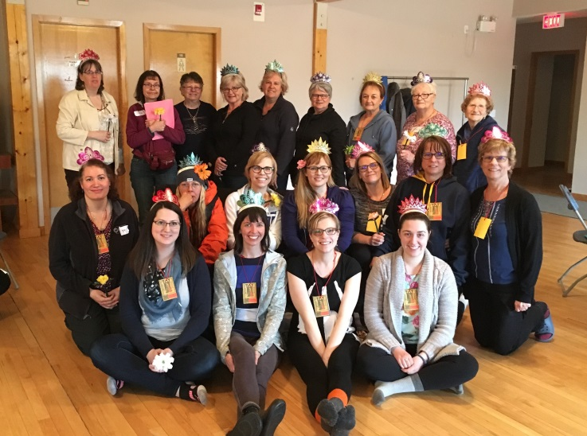 **My beloved is mine and I am His… (Song of Solomon 2:16)**

* The most Beautiful Heart

A young man was proud of his healthy and beautiful heart. One day, standing in the middle of the town, he proclaimed that he had the most beautiful heart in the whole valley. A large crowd gathered to have a look at his heart.  His heart was smooth, shiny and looked very healthy.  Indeed, the man had the most beautiful heart in the valley, everyone agreed.

The proud young man felt delighted and boasted his perfect heart which everyone admired. Suddenly, a voice from the crowd said, “ Your heart is not as beautiful as mine.” The young man searched for the person behind the voice and an old man appeared in front him.

“ Show us your heart if you believe you have got more beautiful heart than mine.” said the young man. The old man carefully showed his heart. The crowd and the young man looked at the old man’s heart.  The heart was beating strongly and healthily but it was not smooth and shiny as the young man’s heart. Instead, it had scars all over it. It had places where some pieces of the heart had been removed and other pieces were put in. The other pieces didn’t fit perfectly and there were several uneven edges. In some places, there were deep gouges where some pieces were missing.

The crowd laughed at the old man’s heart. “How can he claim that he has the most beautiful heart when it is all scared and uneven.”, they thought.

The young man looked at the old man’s heart and laughed.” You must be kidding. Compare your heart and mine. My heart looks perfect and smooth and yours is a mess of scars and tears.”

“Yes, Your heart looks perfect, but I would never trade your heart with mine”, said the old man. “ Every scar in my heart represents a person whom I have given my love. I tear a piece of my heart and give to them. Often, my loved one gives me back a piece of their heart which fits into the empty place in my heart. Since everyone loves each other in a different way. Their piece of heart may not perfectly fit my heart, so you can see some rough edges. These scars and rough edges remind me of the love we shared.”, he continued.

“Sometimes I would give a piece of my heart, but the other person may not return a piece of his heart to me. These are the empty gouges. Although these gouges are painful, these remind me of the love I have for these people too. So do you now see what a true beauty?”asked the old man.

The young man and the crowd stood silently with tears running down their cheeks. The young man walked to the old man, reached into his perfect young and beautiful heart, ripped a piece out of it and offered it to the man with trembling hands.

The old man gratefully received is offering, placed it in his heart and then took a piece from his old heart and placed it in the young man’s heart.

The young man looked at his heart, it did not look shiny and smooth like it used to. But, it was now more beautiful because he could feel the love from the old man’s heart flowing into him.

They embraced and walked away side by side.

The Retreat Facilitator

Denise Laverdure-Sych is a spiritual director, retreat facilitator, mother and Dobrodijka (priest’s wife). She shares in the Ukrainian Catholic priestly ministry with her husband, Fr. Mark Sych, in the St. Paul, Alberta district.

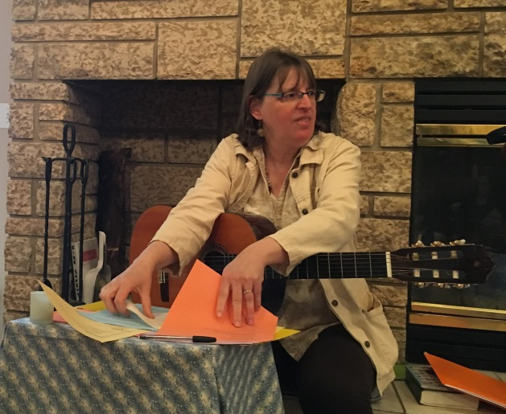Denise grew up in a small town north of Montreal, Quebec and was raised in a dedicated Roman Catholic family. She has a Bachelor of Theology degree from St. Paul University where she met her husband. They have served as pastoral assistants in the Roman Catholic Dioceses of Grouard-McLennan, Alberta, and Mooseonee, Ontario.

As a young adult, Denise worked in community development and lived amongst the poor of Peru for several months. For three years she held the position of pastoral care director in a Lachute, Quebec, health care facility. She has also studied clinical pastoral care education and pastoral counselling towards a Masters in Divinity degree from the University of Winnipeg.

Participation in the *Presence Program* at the Providence Renewal Centre in Edmonton enabled her to become a spiritual director, as a result of which she leads a number of women’s retreats, such as "On The Road To Emmaus" at the St. Edouard Renewal Centre near St.Paul, Alberta and a Catherine Doherty-inspired 24-hour poustinia retreat of fasting and prayer. She also provides spiritual direction to individuals of all ages and denominations.

Denise and Father Mark are raising three adopted daughters and have raised two foster children to adulthood.

Other involvements include the “Second Harvest” community project and “Inclusion Alberta”, an organization of families with children with developmental disabilities.