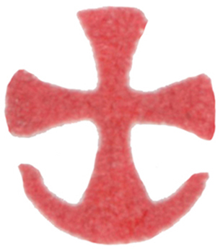 Dec 06: Our Holy Father Nicholas the Wonderworker,
Archbishop of Myra in Lycia (Traditionally ca. 337)

Text from “The Divine Liturgy: An Anthology for Worship”; Pg. 734
Troparion (Tone 4): The truth of your deeds made you for your flock a rule of faith* and an image of meekness,* a teacher of continence.* And so you gained the heights through humility,* riches through poverty,* father and bishop Nicholas.* Intercede with Christ our God* for the salvation of our souls.
+Glory be to the Father and to the Son and to the Holy Spirit. Now and for ever and ever. Amen.
Kontakion (Tone 3): In Myra, O holy one, you proved yourself a priest.* You fulfilled the Gospel of Christ, O venerable father.* You laid down your soul for your people* and saved the innocent from death.* And so you were sanctified as a great initiate of God's grace.
Prokimenon (Tone 7): The just man shall be glad in the Lord, and shall hope in Him
(Ps 63:11).
verse: Hear, O God, my voice, when I make my petition to you (Ps 63:2).
Epistle: (Heb 13:17-21): Brethren, obey your leaders and submit to them, for they are keeping watch over your souls and will give an account. Let them do this with joy and not with sighing—for that would be harmful to you. Pray for us; we are sure that we have a clear conscience, desiring to act honourably in all things. I urge you all the more to do this, so that I may be restored to you very soon. Now may the God of peace, who brought back from the dead our Lord Jesus, the great shepherd of the sheep, by the blood of the eternal covenant, make you complete in everything good so that you may do his will, working among us that which is pleasing in his sight, through Jesus Christ, to whom be the glory for ever and ever. Amen.
Alleluia: Your priests will be clothed with justice; your faithful will shout for joy
(Ps 131:16).
verse: For the Lord has chosen Sion; He has chosen it for His dwelling (Ps 131:13).
Gospel: (Lk 6:17-23) (Feast): At that time Jesus stood on a level place, with a great crowd of his disciples and a great multitude of people from all Judea, Jerusalem, and the coast of Tyre and Sidon. They had come to hear him and to be healed of their diseases; and those who were troubled with unclean spirits were cured. And all in the crowd were trying to touch him, for power came out from him and healed all of them. Then he looked up at his disciples and said: ‘Blessed are you who are poor, for yours is the kingdom of God. ‘Blessed are you who are hungry now, for you will be filled. ‘Blessed are you who weep now, for you will laugh. ‘Blessed are you when people hate you, and when they exclude you, revile you, and defame you on account of the Son of Man. Rejoice on that day and leap for joy, for surely your reward is great in heaven; for that is what their ancestors did to the prophets.
Communion Verse: The just man shall be in everlasting remembrance; of evil hearsay he shall have no fear (Ps 111:6-7). Alleluia! (3x)

