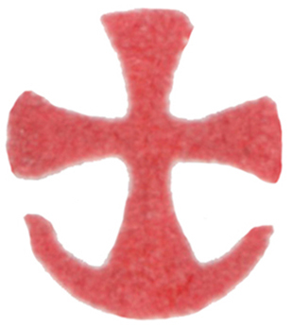
Synaxis of the Archangel Michael and
the Other Bodiless Powers of Heaven
Text from “The Divine Liturgy: An Anthology for Worship”; Pg. 716
Troparion (Tone 4): Princes of the heavenly hosts, * we, though unworthy, beg you * to encircle us through your prayers * under the shelter of the wings of your spiritual glory. * Guard us as we come to you and sincerely cry: * "Deliver us from dangers, * O princes of the powers on high!"
+Glory be to the Father and to the Son and to the Holy Spirit. Now and for ever and ever. Amen.
Kontakion (Tone 4): Princes of God's hosts, ministers of divine glory, * leaders of angels and guides of men, * pray from our welfare and for great mercy, * O princes of the incorporeal powers.
Prokimenon (Tone 4): He makes spirits His angels * and flaming fire His ministers
(Ps 103:4).
verse: Bless the Lord, O my soul; O Lord my God, You are exceedingly great
(Ps 103:1).
Epistle: (Heb 2:2-10) (Feast): Brethren, for if the message declared through angels was valid, and every transgression or disobedience received a just penalty, how can we escape if we neglect so great a salvation? It was declared at first through the Lord, and it was attested to us by those who heard him, while God added his testimony by signs and wonders and various miracles, and by gifts of the Holy Spirit, distributed according to his will. Now God did not subject the coming world, about which we are speaking, to angels. But someone has testified somewhere, ‘What are human beings that you are mindful of them, or mortals, that you care for them? You have made them for a little while lower than the angels; you have crowned them with glory and honour, subjecting all things under their feet.’ Now in subjecting all things to them, God left nothing outside their control. As it is, we do not yet see everything in subjection to them, but we do see Jesus, who for a little while was made lower than the angels, now crowned with glory and honour because of the suffering of death, so that by the grace of God he might taste death for everyone. It was fitting that God, for whom and through whom all things exist, in bringing many children to glory, should make the pioneer of their salvation perfect through sufferings.
Alleluia (Tone 5): Praise the Lord, all you His angels; praise Him, all His powers
(Ps 148:2).
verse: For He spoke, and they came into being; He commanded and they were created (Ps 148:5).
Gospel: (Lk 10:16-21) (Feast): The Lord said to his disciples: ‘Whoever listens to you listens to me, and whoever rejects you rejects me, and whoever rejects me rejects the one who sent me.’ The seventy returned with joy, saying, ‘Lord, in your name even the demons submit to us!’ He said to them, ‘I watched Satan fall from heaven like a flash of lightning. See, I have given you authority to tread on snakes and scorpions, and over all the power of the enemy; and nothing will hurt you. Nevertheless, do not rejoice at this, that the spirits submit to you, but rejoice that your names are written in heaven.’ At that same hour Jesus rejoiced in the Holy Spirit and said, ‘I thank you, Father, Lord of heaven and earth, because you have hidden these things from the wise and the intelligent and have revealed them to infants; yes, Father, for such was your gracious will.
Communion Verse: He makes spirits His angels, and flaming fire his ministers
(Ps 103:4). Alleluia! (3x).

