Arson Risk Management Compliance Declaration

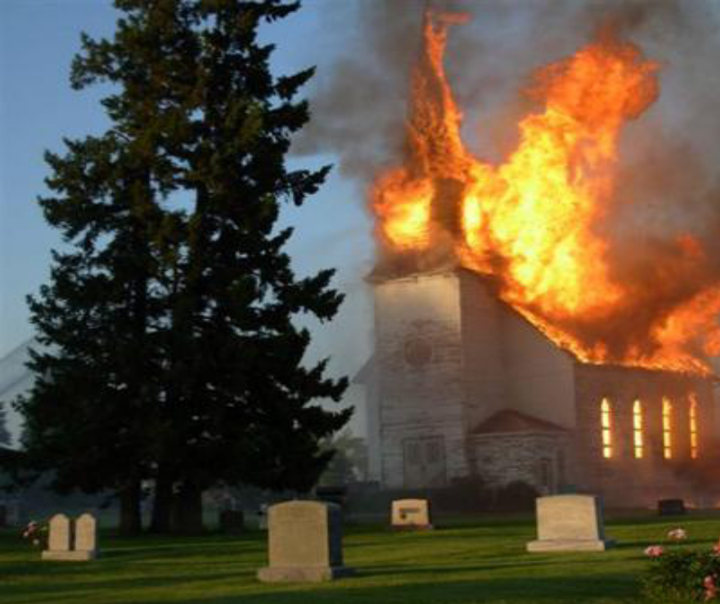

In order to document the compliance with the recommendations contained in the Arson Risk Management Policy, please complete the following declaration and return it to the Chancery Office as soon as possible.

Yes No Comments
The church and grounds are inspected regularly to ensure that recommendations detailed in the Policy (p.2-4) are followed
The “End of Day Checklist” Poster has been displayed in the church
The Churchwatch Program coordinator has been designated and the recommendations detailed in the Policy (p. 6) are being followed

Declaration completed by:
______________________________  Name (Please Print) | Date:
______________________________  Parish Name | ____________________________________  Location #
___________________________________________________________________________
Address of Parish

